WEEK 15

1.OBJECTIVE

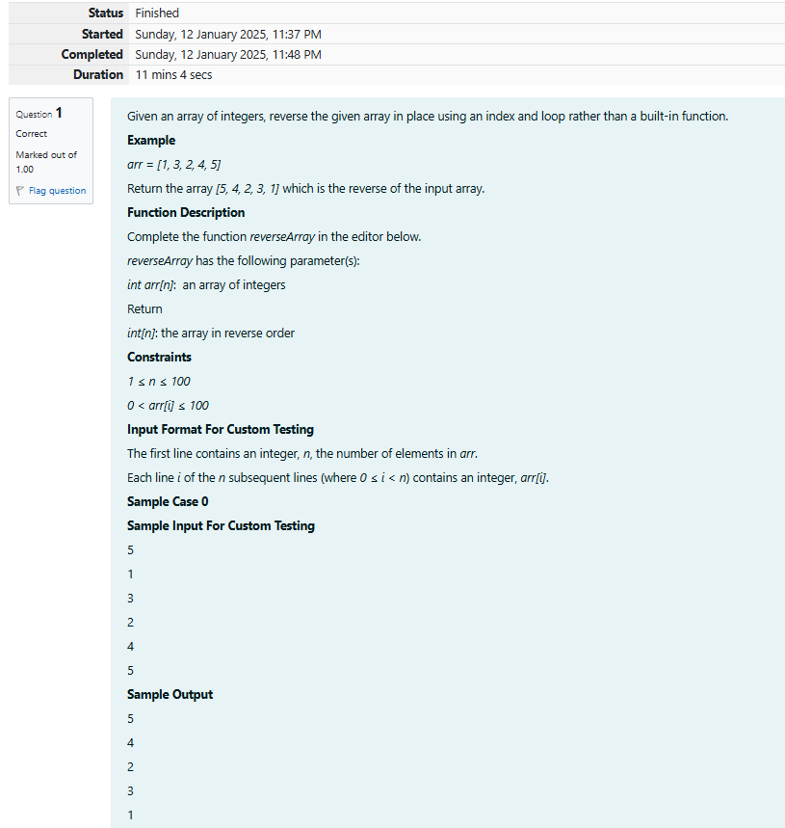

CODE

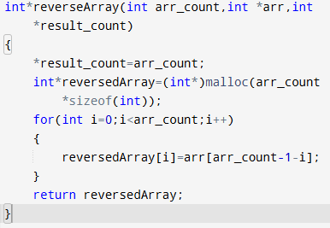

OUTPUT

Test expected got

int arr[]={1,2,3,4,5}; 5 5

int result_count; 4 4

int* result=reverseArray(5,arr,&result_count); 3 3

for(int i=0;i<result_count;i+++ 2 2

printf(“%d\n”,*(result+i)); 1 1

2.OBJECTIVE

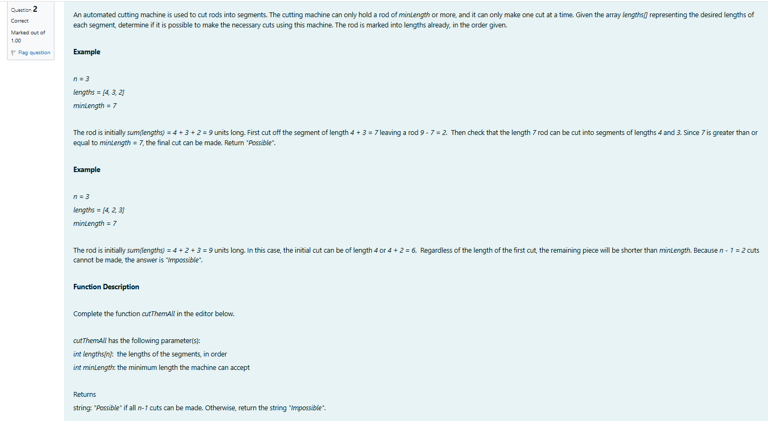

CODE

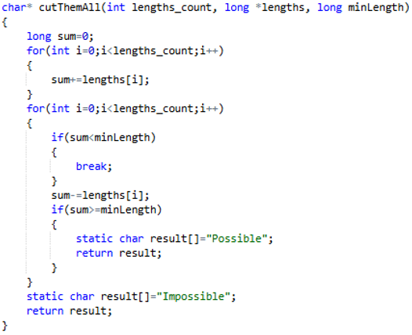

OUTPUT

Test expected got

Long lengths[]={3,5,4,3};

Printf(“%s”,cutThemAll(3,lengths,12)) Impossible Impossible